Cell Decomposition and Visibility Roadmap in Robot Motion Planning
EECS 499 Algorithmic Robotics Course Project

Zifei Yu
Department of Mechanical and Aerospace Engineering
Case Western Reserve University
OH, Cleveland
zxy291@case.edu
Weijia Ye
Department of Mechanical and Aerospace Engineering
Case Western Reserve University
OH, Cleveland
wxy169@case.edu

Abstract—The task of planning trajectories plays an important role in transportation and robotics, etc. in robot motion planning, by given start location and goal location, the robot need to find the shortest path and avoid the obstacle in the map. Research on path planning has yield many different approaches to the salutation of this problem that can be classified as vertical cell decomposition and roadmap method (visibility roadmap),
Keywords— motion planning; cell decomposition; visibility roadmap;

INTRODUCTION
In this paper, we will combine two methods to tack the robot motion problem solution, together with practical implementations using Matlab. The solutions are based on the two classics path planning algorithms, vertical cell decomposition and visibility roadmap. First thing, we will build a static map with several obstacles, according to the different point, using cell decomposition can create a series cells, and combining with visibility roadmap to find the best path from start location to goal location.

Cell decomposition
The basic cell decomposition algorithms can be decomposed into a number of components and the outcome of the search is a sequence of adjacent cells between start and goal from which a continuous path can be computed, however, this approach has many drawbacks such as combinatorial explosion, limited granularity and generating infeasible solutions. This approach can be slightly improved by using other method visibility roadmap.

Visibility roadmap
The other motion planning algorithm is referred to as a visibility roadmap method. The roadmap is built by a set of paths where each path consists of collision free area connections. This method does not have the drawbacks of the previously-method one, we will study them in more detail trying to combine them.

cell decomposition
cell decomposition can be used in path planning in the following way:
- The free space of the polygonal two-dimensional configuration space is determined. The map size is 30*30
- Every polygonal consist with a series of points, according to point’s style can be classified six situations, such as obstacle’s left point, right point and so on, via the different cells cases to determined which one should use up boundaries or down boundaries.
- Determined which cells are adjacent and construct an adjacency graph, the vertices of this graph are cells, and edges join cells that have a common boundary.
- Sweep a line through the space stopping at vertices which are often called events. Maintain a list L of the current edges the slice intersects. Determining the intersection of slice L requires O(n) time but with an efficient data structure like a balanced tree, perhaps O (log n).
- Determined between which two edge the vertex or event lies these edges are lower or upper, and the cells are created the mid of the line segment.

Fig.1 shows a decomposition using vertical line, the color of start is yellow and goal is green. Cells color are red.

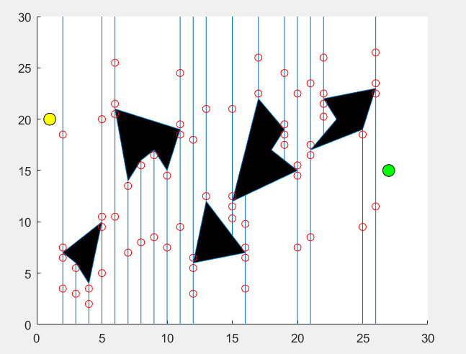
Fig.1
As the fig.1 shows, we just create one cell in each line segment, however, if we want to get better path, the more cell can be created in each line segment, which can increase the complexity of the calculation.
If the robot is not a point and can turn in any direction. Then computing the free space is a major part of calculation. Most method assume a point-sized robot with a fixed orientation and increase the thickness of the wall by the width of the robot.

Software design
- Create map, obstacle, start and goal point
- According to different point style to separate determine which one is left, right and so on
- Then, use the sweep line approach, create the cell locate in mid of line.

visibility roadmap
The most import approaches included in roadmap methods are based on visibility graphs.
A visibility graph is a graph whose vertical include the start, goal and polygonal of the obstacles, its edges are the edges of the obstacles and edges jointing all pairs of verticals that can see each other. And use path algorithms to find the best path from start point to goal point.
In this method, based on the result of the vertical cell decomposition, we need to solve the two problems, one of is how to make the line between the rand two cells avoid the obstacle, the other one is how to find the shortest path from different graphs.
Visibility roadmap can be used in path planning in the following way:
Because based on the result of cell decomposition, we have no need to create the new polygonal obstacles, and all the cell can be used as new obstacle’s node.
- Node are connected if they are already connected by each cell and the line segment joining them is in free space
- Not only is there a path on this roadmap, but it is the shortest path
- If we include the start and goal nodes, they are automatically connected
- Algorithms for constructing them can be efficient

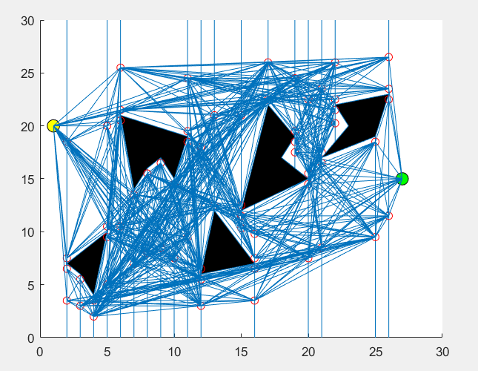

Fig.2 shows the connect cell avoid the obstacle

Softeware design

We need to make each connected cells avoid the obstacle, by determining if the two line segment has a crossover point.
First, two cell and two obstcale’s point can create two line segments, and in order to determine if those line cross, we use the vetor cross product to deal it.
A = X1*Y3-X3*Y1
B = X3*Y2-X2*Y3
When A*B <0, then two line segment not cross. More details can be showed in code package.
X1
X2
X3

The final step, we need to find the best path from those path shown in fig.3

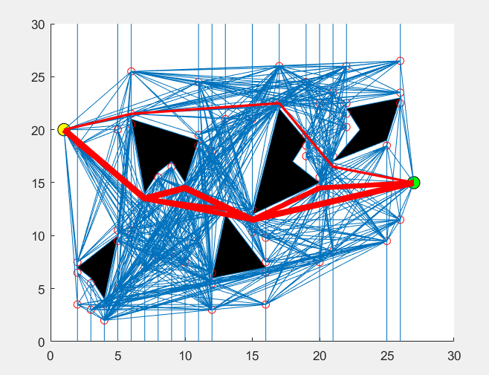

Fig.3 shows the best path based one two path planning algorithms, cell decomposition and visibility roadmap

A Software design
List all the possible routes with no more than 5 path points, choose routes according to the length of the route.

Conclusion
In this paper, we compared cell decomposition and roadmap methods with respect to their advantage, and combine with each other to slightly improve the disadvantage of the cell decomposition.

The more details about path planning as shows the following video link:

Reference

[1] PLANNING ALGORITHMS – Steven M. LaValle, University of Illinois, Published by Cambridge University Press, 2006.

[2] Introduction to Probability — Charles M. Grinstead, Swarthmore College, J.Laurie Snell, Dartmouth College
[3] F. Aurenhammer, Voronoi Diagrams – A Survey of a Fundamental Geometric Data Structure, ACM Computing Surveys, Vol.23, No.3, 1991, pp. 345-405.
[4] M. de Berg, M. van Kreveld, M. Overmars and O. Schwarzkopf, Computational Geometry: Algorithms and Applications, Springer-Verlag, Berlin, 2000.
[5] S. Fortune, Voronoi Diagrams and Delaunay Triangulations, in: D.A. Du and F.K. Hwang (eds.), Euclidean Geometry and Computers, World Scientific Publishing, Singapore, 1992, pp. 193-233.
[6] S. Guha and I. Suzuki, Proximity Problems for Points on a Rectilinear Plane with Rectangular Obstacles, Algorithmica, Vol.17, 1997, pp. 281-307.
[7] M. Kruusmaa and J. Willemson, Covering the Path Space: A Casebase Analysis for Mobile Robot Path Planning, Knowledge-Based Systems, Vol.16, 2003, pp. 235-242.
[8] S.M. LaValle, Planning Algorithms, University Press, Cambridge, 2006.
[9] A. Okabe, B. Boots, K. Sugihara and S.N. Chiu, Spatial Tessellations and Applications of Voronoi Diagrams, John Wiley & Sons, New York., 2000.
[10] M. Ruehl and H. Roth, Robot Motion Planning by Approximation of Obstacles in Configuration Space, 16th IFAC World Congress, Prague, 2005, 6 pp., submitted.
[11] S. Russell and P. Norvig, Artificial Intelligence: A Modern Approach, Prentice Hall, New Jersey, 1995.
[12] M. Šeda, Rectilinear Voronoi Diagram-Based Motion Planning in the Plane with Obstacles, Elektronika (Poland), No. 8-9, 2004, pp. 24-26.
[13] K. Sugihara and J. Smith, Genetic Algorithms for Adaptive Planning of Path and Trajectory of a Mobile Robot in 2D Terrains, IEICE Transactions on Information and Systems, Vol.E82-D, No.1, 1999, pp. 309-317.
[14] P. Švec, Robot Motion Planning Using Computational Geometry (in Czech), Ph.D. Thesis. Brno University of Technology, 2005.
[15] A. Zilouchian and M. Jamshidi, Intelligent Control Systems Using Soft Computing Methodologies, CRC Press, Boca Raton, 2001.

